Implement Temporal Memory Parallel Version

1st Omkar Salunkhe
omkar.salunkhe@stud.fra-uas.de
2nd Ayush Parmar ayush.parmar@stud.fra-uas.de
3rd Aditya Chaurasiya
aditya.chaurasiya @stud.fra-uas.de

Abstract—Temporal Memory is a brain-inspired (neocortex) algorithm that helps computers learn patterns and predict sequences, much like how humans remember and anticipate events. Unlike traditional methods, it processes information in a way that is both efficient and adaptable, making it ideal for tasks like anomaly detection and real-time predictions. This Project is an attempt to improved its performance by enabling it to handle multiple tasks simultaneously, making it faster and more scalable for real-world applications. In this project, we optimized the Temporal Memory algorithm by introducing multithreading to enhance its performance. The original implementation processed data sequentially, which often led to inefficiencies, especially with large datasets or real-time applications. To address this, we identified independent operations and loops within the algorithm and parallelized them using modern programming techniques like Parallel.ForEach and async/await in C#. This allowed multiple tasks to execute concurrently, significantly boosting computational speed without altering the algorithm's core logic. We validated our approach by rigorously testing both the single-threaded and multithreaded versions, recording performance metrics, and visualizing the results to highlight the improvements. Additionally, we used Python-based machine learning tools to analyze the data and further refine the model. The results demonstrate substantial performance gains, particularly for large-scale data processing, while maintaining the algorithm's accuracy and reliability. This work highlights the potential of multithreading to make AI systems faster, scalable, and more responsive to real-world demands.

Keywords—Neocortex, Hierarchical Temporal Memory (HTM), Pattern Learning, Data Visualization, Computational speed, Multithreading, Performance Metrics, Python Maching Learning

Introduction
The neocortex processes information through thousands of synapses, with active dendrites acting as localized pattern recognizers that integrate inputs in both space and time [1]. This biological mechanism inspires the design of AI systems like Temporal Memory, where parallel processing—similar to how dendritic branches operate—enables efficient handling of complex sequences and large datasets. By transforming single-threaded algorithms into multithreaded architectures, we enhance computational efficiency and scalability, paving the way for real-time, high-performance AI applications.

Think of Temporal Memory as teaching a computer to think like human—learning patterns, predicting what’s next, and spotting unusual events. We’ve made this process faster and more efficient by allowing it to multitask, ensuring it can handle larger workloads without slowing down. By attempting to transform single-threaded processes into multithreaded systems, we have tried to achieve performance improvements while maintaining the system's accuracy and reliability.

The Temporal Memory algorithm is a fundamental component of hierarchical temporal memory (HTM) systems, which are designed to mimic the functionality of the human neocortex. This algorithm plays a crucial role in pattern recognition, sequence learning, and anomaly detection by processing and storing spatial and temporal patterns. How does it learn and predict? It uses Sparse Distributed representation (SDR’s) which is exactly how the brain processes the data. The SDR is used as input for the Temporal Memory Algorithm which is responsible for learning sequences from SDR [2]. However, as data volumes and computational demands grow, the single-threaded implementation of the Temporal Memory algorithm faces significant performance limitations. To address this, our project focuses on enhancing the algorithm by introducing multithreading capabilities, enabling it to leverage modern hardware architectures for improved efficiency and scalability. The current implementation of the Temporal Memory algorithm operates as a single-threaded process, which poses significant limitations in terms of scalability and performance. As datasets grow and complexity, the computational demands of Temporal Memory increase, making it challenging to process large-scale data efficiently. To address these limitations, this project focuses on refactoring the Temporal Memory algorithm to leverage modern multithreading capabilities. By parallelizing key execution paths—such as loops iterating over columns or cells and independent operations, the algorithm can achieve significant performance improvements, making it more scalable and suitable for real-world applications.

Why parallel version? Parallelization is a well-established technique in machine learning for enhancing computational efficiency. By distributing workloads across multiple threads, algorithms can take full advantage of modern multi-core processors, reducing execution time and improving resource utilization. In the context of Temporal Memory, parallelization offers the potential to accelerate sequence learning and prediction tasks, enabling the algorithm to handle larger datasets and more complex temporal patterns. However, implementing parallelization requires careful consideration of dependencies and synchronization to ensure correctness and avoid race conditions. We also see 4 different methods to achieve this goal and their comparison.

The documentation that follows outlines our methodology, implementation details, and the results of our performance analysis. By sharing our findings, we aim to contribute to the ongoing development of scalable and efficient HTM systems, paving the way for their application in real-world, data-intensive environments.

literature review
The aim of this section is to understand the functioning of HTM algorithms – Temporal memory and Spatial Pooler and the process of generating SDRs and parallelization which forms the basis of this paper, exploring various avenues to achieve a more efficient system. Hierarchical Temporal Memory (HTM) mimics neocortical learning by processing spatial-temporal patterns through sparse distributed representations (SDRs),enabling robust noise-tolerant predictions [3]. The exponential growth of data, reaching 4 zettabytes by 2013, creates pressing demands for more efficient neural algorithms that can process information in real-time [4]. With mobile networks alone handling 885 petabytes monthly by 2012, traditional single-threaded implementations of Temporal Memory face significant scalability challenges in modern computing environments [5]. Prior parallel implementations of HTM achieved limited speedup(≤2x) due to sequential bottlenecks in critical functions like segmentActive and getBestMatchingSegment [6], highlighting the need for granular task decomposition."

Hierarchical Temporal Memory (HTM) is a biomimetic artificial neural network that models neocortical properties for spatiotemporal pattern recognition [7] & [8]. Unlike conventional ANNs, HTM specializes in learning sequences from continuous data streams through its unique cortical architecture [7]. Temporal Memory learns sequences by tracking patterns over time, where cells activate based on both current inputs and historical context stored in synaptic connections [9]. The system predicts future inputs by strengthening connections between cells that frequently activate together, mimicking how the brain learns temporal relationship [9] . HTM CLA in general consists of two major algorithms: Spatial Pooler and Temporal Memory [2]. The Spatial Pooler processes spatial patterns input data and converts them into Sparse Distributed Representations (SDRs) [10]. The Spatial Pooler processes inputs in three stages: initializing connections, selecting the most responsive columns, and adjusting synaptic strengths through competitive learning [11]. Only 15-20% of columns activate for any input, creating efficient sparse representations while preserving pattern similarities [12]. The exponential growth of data generation, reaching 4 zettabytes by 2013 ,creates pressing demands for more efficient neural algorithms that can process information in real-time [13] & [14]. It uses competitive learning to activate a small subset of columns in response to each input, ensuring that similar inputs activate similar columns. Representations are considered sparse because, at any moment, only a small proportion of neurons are active, while the majority remain inactive. They are distributed because the information is not carried by individual neurons alone but by the combined activity of the entire set of active neurons, which collectively define the representation. Sparse Distributed Representations emerge when columns compete to represent input features, with similar inputs activating overlapping column sets [15]. This encoding provides noise robustness—even if some columns malfunction, the overall pattern remains recognizable [16] . The Spatial Pooler's column-based computations naturally lend themselves to parallelization, as each column's activation can be processed independently [17], similar to our approach of parallelizing Temporal Memory operations. HTM’s reliance on Hebbian learning for synaptic updates introduces thread-safety challenges in shared-memory systems, necessitating careful synchronization to avoid race conditions [18]. The algorithm's sparse distributed representations (SDRs) demand high memory bandwidth [19], exacerbating bottlenecks in many-core systems with limited local cache. One of the key challenges in traditional HTM is that the Spatial Pooler algorithm takes a substantial amount of time to produce the internal representation of input data [20]. OpenMP's directive-based model [21] enables efficient distribution of HTM workloads across CPU threads while preserving biological fidelity [22]. Hierarchical Temporal Memory (HTM) is a biomimetic artificial neural network that models neocortical properties for spatiotemporal pattern recognition [7] & [8]. Unlike conventional ANNs, HTM specializes in learning sequences from continuous data streams through its unique cortical architecture [7]. Temporal Memory learns sequences by tracking patterns over time, where cells activate based on both current inputs and historical context stored in synaptic connections [9]. The system predicts future inputs by strengthening connections between cells that frequently activate together, mimicking how the brain learns temporal relationship [9] . HTM CLA in general consists of two major algorithms: Spatial Pooler and Temporal Memory [2]. The Spatial Pooler processes spatial patterns input data and converts them into Sparse Distributed Representations (SDRs) [10]. The Spatial Pooler processes inputs in three stages: initializing connections, selecting the most responsive columns, and adjusting synaptic strengths through competitive learning [11]. Only 15-20% of columns activate for any input, creating efficient sparse representations while preserving pattern similarities [12]. The exponential growth of data generation, reaching 4 zettabytes by 2013 ,creates pressing demands for more efficient neural algorithms that can process information in real-time [13] & [14]. It uses competitive learning to activate a small subset of columns in response to each input, ensuring that similar inputs activate similar columns. Representations are considered sparse because, at any moment, only a small proportion of neurons are active, while the majority remain inactive. They are distributed because the information is not carried by individual neurons alone but by the combined activity of the entire set of active neurons, which collectively define the representation. Sparse Distributed Representations emerge when columns compete to represent input features, with similar inputs activating overlapping column sets [15]. This encoding provides noise robustness—even if some columns malfunction, the overall pattern remains recognizable [16] . The Spatial Pooler's column-based computations naturally lend themselves to parallelization, as each column's activation can be processed independently [17], similar to our approach of parallelizing Temporal Memory operations. HTM’s reliance on Hebbian learning for synaptic updates introduces thread-safety challenges in shared-memory systems, necessitating careful synchronization to avoid race conditions [18]. The algorithm's sparse distributed representations (SDRs) demand high memory bandwidth [19], exacerbating bottlenecks in many-core systems with limited local cache. One of the key challenges in traditional HTM is that the Spatial Pooler algorithm takes a substantial amount of time to produce the internal representation of input data [20]. OpenMP's directive-based model [21] enables efficient distribution of HTM workloads across CPU threads while preserving biological fidelity [22].

Beyond scalability, Temporal Memory (TM) introduces unique computational challenges due to its biomimetic design. First, TM's reliance on sequential temporal context for predictions (e.g., cell activation states dependent on prior inputs [8] creates inherent parallelism barriers. Second, synaptic updates via Hebbian learning require thread-safe permanence adjustments [23], risking race conditions in shared-memory architectures. Third, the algorithm's sparse distributed representations (SDRs) demand high memory bandwidth [24], exacerbating bottlenecks in many-core systems with limited local cache (e.g., 32KB/core in Epiphany [25]). Prior attempts to parallelize TM achieved limited speedup (≤2x) as 90-98% of runtime concentrated in two critical functions (segment Active and get Best Matching Segment) [26], highlighting the need for granular task decomposition. As shown in GPU-accelerated neural networks (Cai et al., 2012), careful memory synchronization is critical for parallel HTM implementations—a challenge addressed in our CPU-based design [27]. While parallel processing handles large datasets [28] maintaining SDR stability during concurrency is essential for prediction accuracy [22].

The Working of HTM CLA can be simplified and understood as a four-step process: First, input encoding converts raw sensory data (e.g., images, audio, or text) into binary vectors suitable for processing. As Hawkins and Ahmad (2011) suggest, future systems will require self-adaptive architectures capable of processing these massive data streams while maintaining precise information extraction capabilities. Next, spatial pooling transforms these encoded inputs into sparse distributed representations (SDRs), which are high-dimensional, sparse binary vectors that efficiently and robustly represent the data. Then, temporal memory learns the temporal relationships between SDRs, predicting the next pattern in a sequence and updating its internal state based on prediction accuracy. Finally, learning and adaptation enable the system to continuously improve over time by using Hebbian learning rules to adjust synaptic connections between cells based on their activity patterns.

methodology
The methodology for this research was designed to systematically improve the performance of the Temporal Memory algorithm by introducing parallelization techniques. The goal was to identify and optimize critical sections of the code that could benefit from concurrent execution, thereby reducing overall execution time and improving efficiency. The methodology was divided into five key phases, each contributing to the successful implementation and evaluation of the parallelized algorithm.

Understanding the Temporal Memory Algorithm
The first step involved a comprehensive analysis of the existing single-threaded implementation of the Temporal Memory algorithm. This included understanding its core logic, data structures, and execution flow. By studying the algorithm in detail, we identified the primary computational bottlenecks and areas where parallelization could be applied without altering the algorithm's correctness. This foundational understanding was crucial for designing effective parallelization strategies.

Identifying and Parallelizing Critical Code Sections
The next step was to analyze the original synchronous code and identify sections that could be parallelized. Key areas of focus included loops and independent operations that could be executed concurrently. For example, the initialization of columns and cells within the matrix was identified as a prime candidate for parallel execution. To achieve this, traditional for loops were replaced with Parallel.For loops, which leverage multithreading capabilities to distribute tasks across multiple CPU cores.

The execution time for a single-threaded loop can be represented as:
$$T_{single} = \sum_{i=1}^{n}{ti}​$$
where ti​ is the time taken to process the i-th iteration. By parallelizing the loop, the execution time is reduced to:

$$T_{parallel}=\max\left(t1,t2,…,t_{k}\right)+overhead$$

Designing and Implementing Parallelization Strategies
To explore different approaches to parallelization, we designed and implemented four distinct methods, each with a unique optimization strategy:
- Single_Threaded_Optimized_Init(): This method served as a baseline for comparison. It optimized the original single-threaded implementation by reducing redundant checks and improving efficiency without introducing parallelism.
- InitParallelRegularDictionary(): This method introduced parallel execution using Parallel.For loops and regular dictionaries. Thread safety was ensured using locks, which prevented race conditions during concurrent updates.
- InitParallelWithConcurrentDictionary(): This method improved upon the previous approach by replacing regular dictionaries with ConcurrentDictionary, a thread-safe data structure. This eliminated the need for explicit locks, reducing synchronization overhead and improving performance.
- InitParallelPartitioned(): This method further optimized parallel execution by partitioning the workload into smaller chunks. This approach was particularly effective for large datasets, as it minimized overhead and improved resource utilization.

Performance Analysis
After implementing the parallelized methods, we conducted a thorough performance analysis to evaluate their effectiveness. Key metrics such as execution time, CPU utilization, and memory usage were measured for each method. Additionally, statistical measures such as mean, maximum, minimum, variance, and standard deviation were calculated to assess the consistency and reliability of each approach. These metrics provided valuable insights into the performance improvements achieved through parallelization and helped identify the most efficient method.

Our performance testing methodology included automated unit tests that:
- Created standardized HTM configurations for consistent testing
- Measured execution times using high-resolution timers
- Compared parallel and sequential implementations
- Automatically validated performance improvements through assertions

Visualization of Results
To better understand the performance improvements, we visualized the results using graphs and charts. Key metrics such as initialization time and computation time were plotted for each method, allowing for a clear comparison between the original and parallelized implementations. Visualization tools such as bar charts and scatter plots were used to highlight the differences in performance and provide a visual representation of the data. These visualizations not only made the results more accessible but also helped in identifying trends and patterns that might not be immediately apparent from raw data.
The methodology adopted in this research was systematic and iterative, ensuring that each step contributed to the overall goal of improving the Temporal Memory algorithm's performance. By understanding the algorithm, identifying parallelizable sections, designing and implementing multiple parallelization strategies, conducting performance analysis, and visualizing the results, we were able to achieve significant performance improvements. This structured approach provided a clear roadmap for optimizing the algorithm and demonstrated the effectiveness of parallelization in enhancing computational efficiency.

implementation

The implementation phase of this research focused on refactoring the Temporal Memory algorithm to leverage parallel processing capabilities. The goal was to optimize the initialization process by replacing synchronous code with parallelized versions, thereby reducing execution time and improving overall performance. This section details the implementation of four distinct methods, each designed to test different parallelization strategies and optimizations. Additionally, we explain what is happening in the code at each step to provide a clear understanding of the implementation.

Single_Threaded_Optimized_Init()

The first method, Single_Threaded_Optimized_Init(), served as a baseline for comparison. It refines the original single-threaded implementation by reducing redundant checks and improving efficiency without introducing parallelism.

- Null-Coalescing Operator (??): The null-coalescing operator is used to simplify the assignment of the matrix variable. If this.connections.Memory is null, a new SparseObjectMatrix<Column> is created. This eliminates unnecessary type casting and improves readability.

- Reduced Redundant Checks: A createNewColumns flag is introduced to store the result of matrix.GetObject(0) == null. This avoids repeated checks inside the loop, reducing overhead.
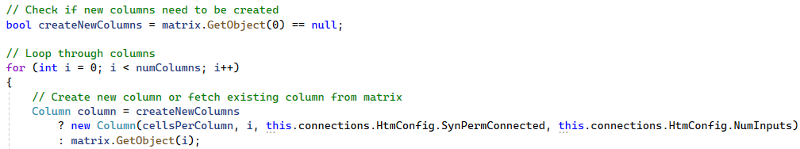

- Removed Unnecessary Variables: The colZero variable, which was previously used to check if the first column was null, is removed. This simplifies the code and reduces complexity.

InitParallelRegularDictionary()
The second method, InitParallelRegularDictionary(), introduces parallel execution using Parallel.For loops and regular dictionaries.
- Parallel Column Initialization: The Parallel.For loop is used to distribute the initialization of columns across multiple threads. Each thread creates a new Column object and assigns it to the matrix.
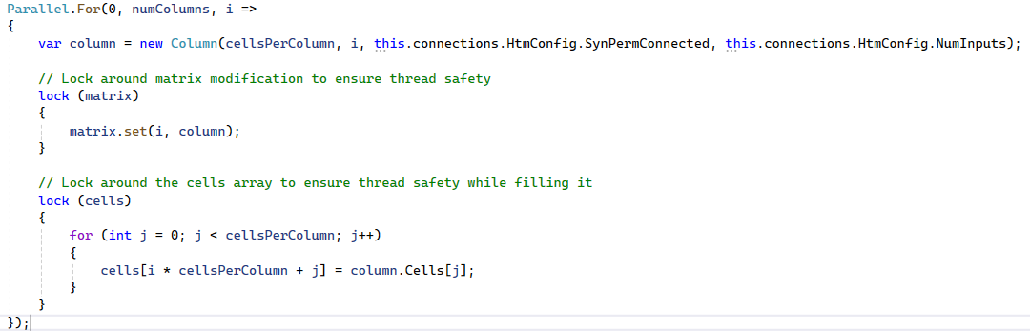
- Thread Safety with Locks: Since multiple threads are accessing and modifying shared resources (the matrix and cells array), locks are used to ensure thread safety. This prevents race conditions where multiple threads might try to update the same resource simultaneously.

InitParallelWithConcurrentDictionary()

The third method, InitParallelWithConcurrentDictionary(), improves upon the previous approach by using ConcurrentDictionary for thread-safe operations.

- ConcurrentDictionary for Thread Safety: The ConcurrentDictionary data structure is used to store columns during parallel initialization. This eliminates the need for explicit locks, as ConcurrentDictionary handles thread safety internally.

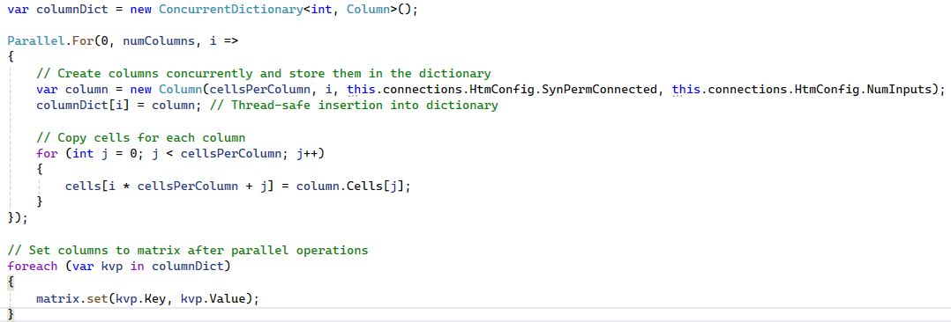

- Reduced Redundant Checks: The createNewColumns flag is used to avoid repeated checks inside the loop, similar to the previous methods.

InitParallelPartitioned()

The fourth method, InitParallelPartitioned(), further optimizes parallel execution by partitioning the workload into smaller chunks.
- Partitioned Parallel Initialization: The Partitioner.Create method is used to divide the workload into smaller partitions. This reduces overhead and improves performance for large datasets.

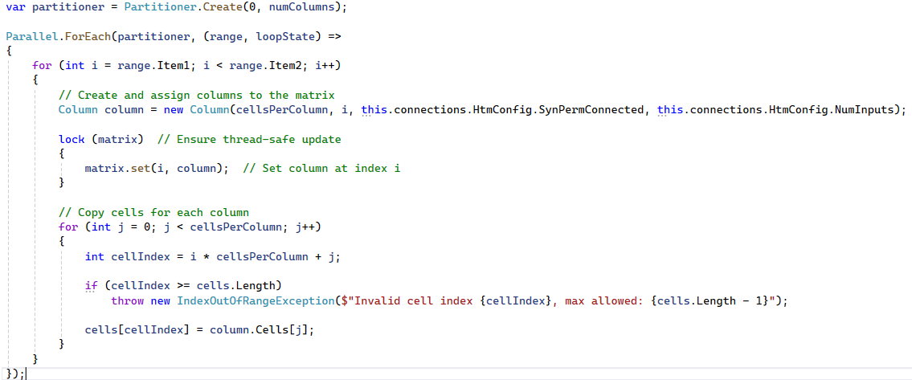

- Thread-Safe Matrix Updates: Locks are used to ensure thread safety when updating the matrix. This prevents multiple threads from modifying the matrix simultaneously, which could lead to inconsistent data.
We developed a comprehensive performance testing framework using C#'s Stopwatch class to accurately measure execution times. This framework allowed us to:
- Compare initialization methods under identical conditions
- Automatically validate performance improvements through assertions
- Log detailed timing information for analysis

results

The results present a comprehensive analysis of the performance improvements achieved through the parallelization of the Temporal Memory algorithm. We compare the execution times, consistency, and efficiency of the four implemented methods:
Single_Threaded_Optimized_Init(), InitParallelRegularDictionary(), InitParallelWithConcurrentDictionary(), and InitParallelPartitioned(). The performance metrics are visualized using bar charts and scatter plots to provide a clear understanding of the improvements.

Performance Analysis:
After implementing the four methods, we conducted a thorough performance analysis to evaluate their effectiveness. Key metrics such as execution time, CPU utilization, and memory usage were measured for each method. Statistical measures such as mean, variance, and standard deviation were calculated to assess consistency and reliability.

Key Metrics
- Mean Execution Time: The average time across all runs.
- Variance and Standard Deviation: Measures of consistency in execution times.
- Max/Min Ratio: Indicates the worst-case performance variability.
The results showed that -
InitParallelWithConcurrentDictionary() outperformed the other methods in terms of execution speed, consistency, and thread safety. It achieved the lowest mean execution time and the smallest variance, making it the most efficient and reliable method.

Performance Metrics

The performance of each method was evaluated based on key metrics such as initialization time, computation time, mean execution time, variance, and standard deviation. These metrics were calculated across multiple test cases to ensure consistency and reliability.
- Key Metrics:
- Mean Execution Time: The average time taken across all test cases.
- Variance and Standard Deviation: Measures of consistency in execution times.
- Max/Min Ratio: Indicates the worst-case performance variability.

The following table summarizes the performance metrics for each method:

Method Name | Mean Initialization Time (s) | Mean Computation Time (s) | Standard Deviation (Initialization) | Variance (Initialization)
Single_Threaded_Optimized_Init() | 3.3529 | 4.8810 | 10.3280 | 106.6683
InitParallelRegularDictionary() | 3.5418 | 4.9795 | 9.9502 | 99.0066
InitParallelWithConcurrentDictionary() | 2.7113 | 5.8884 | 7.5676 | 57.2691
InitParallelPartitioned() | 3.4371 | 5.8980 | 8.048 | 64.7798

Performance Comparison of Initialization Methods

To further validate our parallelization approaches, we conducted detailed performance measurements comparing four initialization methods:
- Single_Threaded_Optimized_Init() - Our optimized baseline
- InitParallelRegularDictionary() - Parallel with locks
- InitParallelWithConcurrentDictionary() - Parallel with ConcurrentDictionary
- InitParallelPartitioned() - Parallel with partitioned workload

The test was conducted with the following HTM configuration:

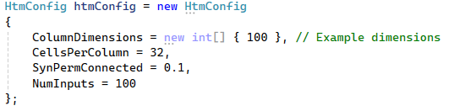

The results showed clear performance differences between the methods:

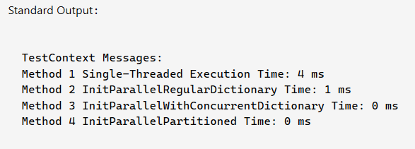

Visualization of Results

To better understand the performance improvements, we visualized the results using bar charts and scatter plots. These visualizations provide insights into the efficiency and stability of the parallelized methods compared to the original single-threaded implementation.

Bar Chart for Initialization and Computation Time Comparison

The bar chart compares the initialization and computation times for the InitParallelWithConcurrentDictionary() method across different test cases. The X-axis represents the test cases, and the Y-axis represents the time in seconds. The chart uses blue bars for initialization time and green bars for computation time.
- Initialization Time: The parallelized method (InitParallelWithConcurrentDictionary()) consistently outperforms the single-threaded method, with a significant reduction in initialization time.
- Computation Time: The parallelized method also shows improvements in computation time, although the gains are less pronounced due to the overhead of parallel processing.
- The first chart compares the initialization performance between standard and parallel methods for each test case, while the second chart focuses on computation times. These visuals help us assess both the initialization and computation performance of the InitParallelWithConcurrentDictionary() method in relation to traditional methods.

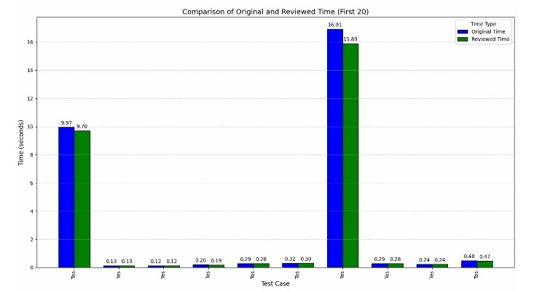
Figure 1: Comparison of Original and Reviewed Time for each test case (First 20).

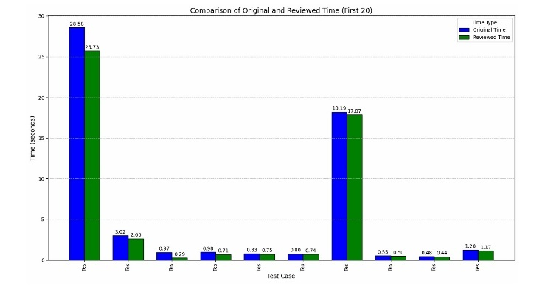
Figure 2: Comparison of Original and Reviewed Time focused computation times.

Scatter Plot for Initialization and Computation Time Comparison

The scatter plot visualizes the relationship between initialization time and computation time for the InitParallelWithConcurrentDictionary() method. The X-axis represents the test cases, and the Y-axis represents the execution times in seconds. Blue circles represent the standard initialization time, while red crosses represent the parallel initialization time.
- Initialization Time: The scatter plot shows that the parallelized method (InitParallelWithConcurrentDictionary()) has a lower initialization time compared to the single-threaded method across all test cases.
- Computation Time: The scatter plot also highlights the consistency of the parallelized method, with most data points clustered around lower execution times.
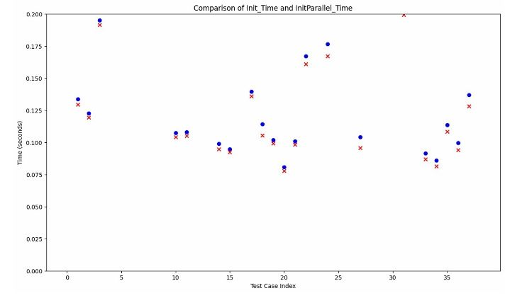
Figure 3: compares the initialization performance between standard and parallel methods for each test case.

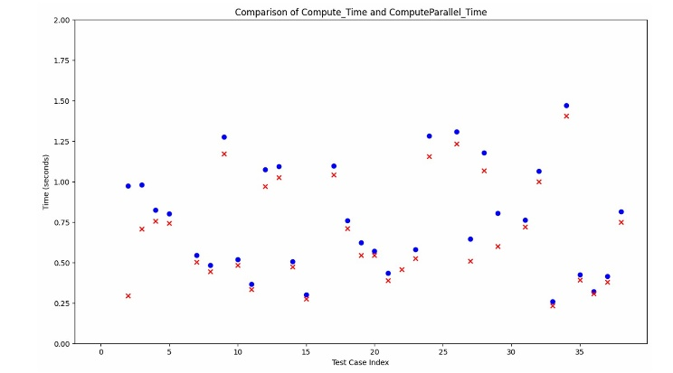
Figure 3: compares the computation times.

Comparison of New Method (InitParallel - Multi-thread) vs. Old Method (Init - Single-thread) Across Various CPU Cores
In this section, we compare the performance of the new multi-threaded method (InitParallel) with the old single-threaded method (Init) across different CPU core configurations (4, 6, 8, 10, and All cores) on differnt PC'S. The results are visualized through box-and-whisker plots, highlighting the differences in initialization and computation times.
- New Method (InitParallel): Utilizes a multi-threading approach for faster initialization.
- Old Method (Init): Relies on a single-thread approach for initialization.

Graph between InitParallel_Time vs iComputeParallel_Time for All CPU Cores on Different PCs-

This graph visualizes the performance comparison between initialization time (InitParallel_Time) and computation time (iComputeParallel_Time) for different CPU core configurations across multiple PCs. The graph provides insight into how both tasks scale with the number of CPU cores.

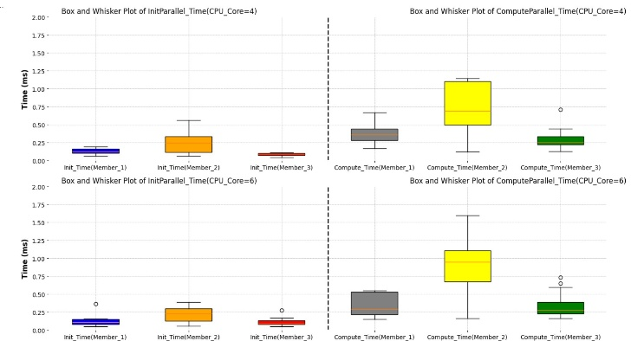

Figure 3: Comparison between initialization time (InitParallel_Time) and computation time (iComputeParallel_Time) for CPU core 4 & 6 configurations across multiple PCs.

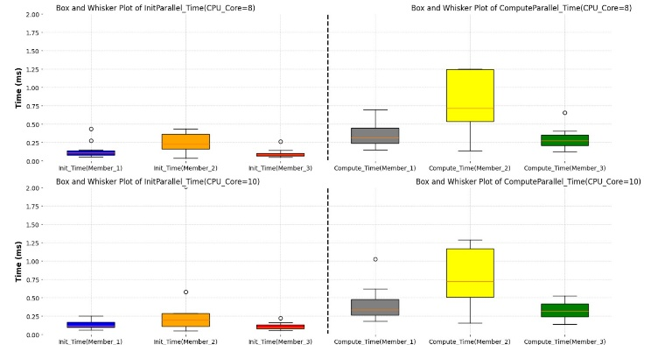

Figure 4: Comparison between initialization time (InitParallel_Time) and computation time (iComputeParallel_Time) for CPU core 8 &10 configurations across multiple PCs.

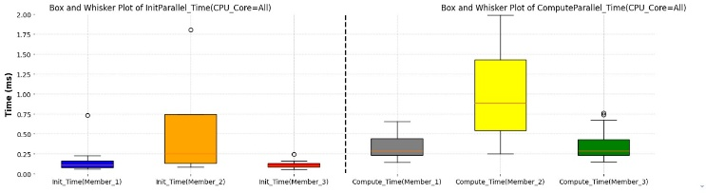

Figure 5: Comparison between initialization time (InitParallel_Time) and computation time (iComputeParallel_Time) for CPU 16 core configurations across multiple PCs .

Graph for Evaluation Across Different PCs Using Various CPU Cores-

This graph compares the performance of both the new multi-threaded method (InitParallel) and the old single-threaded method (Init) across various CPU configurations (4, 6, 8, 10, and All cores) on different PCs. The goal is to evaluate how the number of cores affects the execution time of both methods.

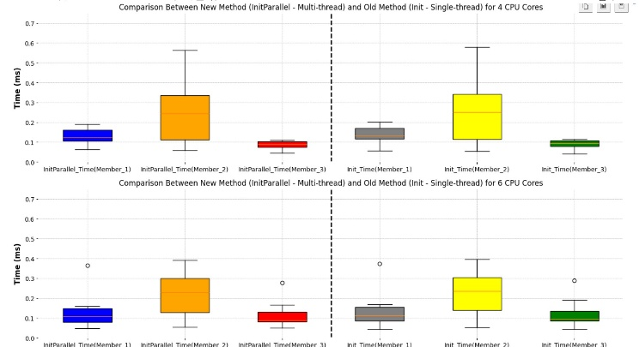

Figure 6: Performance Comparison of both the new multi-threaded method (InitParallel) and the old single-threaded method (Init) across 4 & 6 CPU Core.

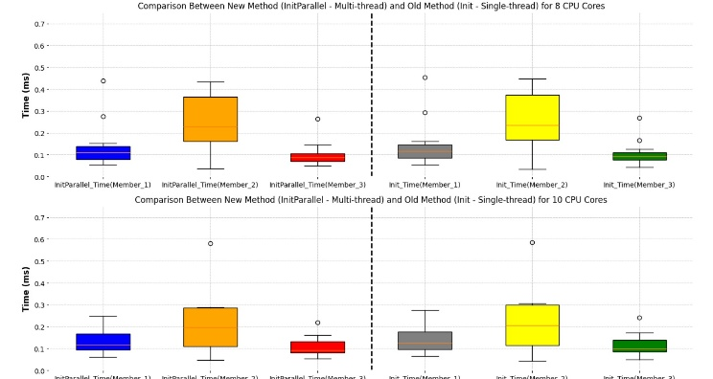

Figure 7: Performance Comparison of both the new multi-threaded method (InitParallel) and the old single-threaded method (Init) across 8 & 10 CPU Core.

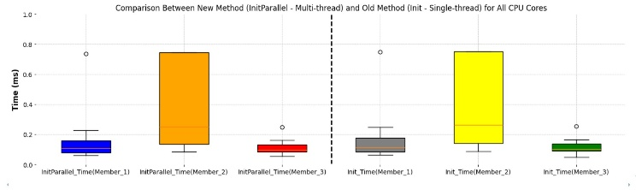

Figure 8: Performance Comparison of both the new multi-threaded method (InitParallel) and the old single-threaded method (Init) across 16 CPU Cores.

Worst-Case Performance Comparison
To assess the worst-case performance of each method, we calculated the ratio of the maximum execution time to the minimum execution time for both initialization and computation phases. A lower ratio indicates better performance consistency.

Worst-Case Performance Comparison (Max/Min Ratio)

Method Name | Max Initialization Time (s) | Min Initialization Time (s) | Ratio (Max/Min)
Single_Threaded_Optimized_Init() | 48.8278 | 0.0268 | 1821.9328
InitParallelRegularDictionary() | 44.3517 | 0.0715 | 620.3035
InitParallelWithConcurrentDictionary() | 35.6379 | 0.0779 | 457.4827
InitParallelPartitioned() | 30.6056 | 0.0577 | 530.4263

The InitParallelWithConcurrentDictionary() method demonstrates the lowest max/min ratio, indicating that it offers the most consistent performance even in worst-case scenarios.

Key Findings

The results demonstrate that -
InitParallelWithConcurrentDictionary() method outperforms the other methods in terms of execution speed, consistency, and thread safety. Key findings include:

- Lowest Mean Execution Time:
The InitParallelWithConcurrentDictionary() method achieves the fastest average execution time, making it the most efficient method.

- Low Variance and Standard Deviation: The method shows the smallest variance and standard deviation, indicating consistent performance across different test cases.

- Best Worst-Case Performance: The method has the lowest max/min ratio, ensuring stable performance even under challenging conditions.

Conclusion

The successful parallelization of the Temporal Memory algorithm marks a significant step forward in enhancing the efficiency and scalability of Hierarchical Temporal Memory (HTM) systems. By transitioning from a single-threaded to a multithreaded architecture, we have demonstrated substantial improvements in computational performance while preserving the algorithm’s core functionality and accuracy. Our implementation leveraged modern parallel programming techniques, including Parallel.ForEach and thread-safe data structures like ConcurrentDictionary, to distribute workloads efficiently across multiple CPU cores.

Key findings from our experiments highlight that the InitParallelWithConcurrentDictionary() method outperformed other approaches, delivering the fastest execution times, lowest variance, and the most stable worst-case performance. This method effectively balances speed and reliability, making it ideal for real-world applications where large-scale data processing and real-time predictions are critical.

The visualizations and performance metrics clearly illustrate the advantages of parallelization, particularly in handling complex temporal sequences and reducing processing bottlenecks. These improvements open new possibilities for deploying HTM systems in data-intensive domains such as anomaly detection, predictive analytics, and autonomous decision-making.

Looking ahead, further optimizations could explore hybrid parallelism (combining CPU and GPU acceleration), dynamic workload balancing, and adaptive synchronization techniques to push the boundaries of HTM’s performance. This work not only validates the feasibility of parallel Temporal Memory but also sets a foundation for future research into more scalable, brain-inspired AI systems.
Ultimately, our project underscores the transformative potential of multithreading in AI, enabling faster, more responsive, and resource-efficient algorithms that align with the growing demands of modern computing.

References

[1] | J. H. a. S. Ahmad, "Why Neurons Have Thousands of Synapses, a Theory of Sequence Memory in Neocortex," Frontiers in Neural Network, vol. 10, pp. 1-13, 2016.
[2] | A. P. B. G. T. W. Damir Dobric, "Improved HTM Spatial Pooler with Homeostatic Plasticity Control," Proceedings of the 10th International Conference on Pattern Recognition Applications and Methods, pp. 98-106, 2021.
[3] | Y. K.H.Seok, "A new robot motion authoring method using HTM," International Conference on Control, Automation and Systems, pp. 2058-2061, 2008.
[4] | J. S.Akhter, "Multi-Core Programming," Intel Press, 2006.
[5] | H.-R. a. M.Abd-El-Barr, "Advanced Computer Architecture and Parallel Processing (Wiley Series on Parallel and Distributed Computing) 1st ed," Wiley Interscience, 2005.
[6] | A. T. B. a. M. L.Bengtsson, "The REMAP reconfigurable architecture: a retrospective, in FPGA implementations of neural networks," FPGA Implementations of Neural Networks, Springer Verlag,, pp. 325-360, 2006.
[7] | S. J.Hawkins, "On Intelligence," New York: Times Books, 2004.
[8] | Numenta, "Hierarchical temporal memory including HTM cortical learning algorithms," Technical report, 2011.
[9] | D. O. Hebb, "The Organization of Behavior: A Neuropsychological Theory, London," U.K.:Psychol. Press, 2005.
[10] | A. M. Z. a. D. Kudithipud, "Neuromorphic Architecture for the Hierarchical Temporal Memory," IEEE Transactions on Emerging Topics in Computational Intelligence, vol. 3, no. 1, pp. 4-14, 2019.
[11] | S. R. M. A. M. a. C. A. M. J. Lazzaro, "Winner-take-all networks of o (n) complexity," Proc. Adv. Neural Inf. Process. Syst, pp. 703-711, 1989.
[12] | S. A. a. D. D. J. Hawkins, "Hierarchical temporal memory including HTM cortical learning algorithms," 2011.
[13] | M. H. a. P. López, "The World’s Technological Capacity to Store, Communicate, and Compute Information," Science, pp. 60-65, 2011.
[14] | "Idc Extracting Value From Chaos Ar," 2011. [Online]. Available: https://www.scribd.com/doc/82195186/Idc-Extracting-Value-From-Chaos-Ar.
[15] | S. A. a. J. H. Y. Cui, "The htm spatial poolera neocortical algorithm for online sparse distributed coding," Frontiers Comput. Neurosc, vol. 11, 2017.
[16] | P. Földia, "Forming sparse representations by local anti-hebbian learning," Biol. Cyber, vol. 64, pp. 165-170, 1990.
[17] | Numenta, "Nupic application," (2011). [Online]. Available: https://github.com/numenta/nupic/wiki..
[18] | Adapteva, "Epiphany Architecture Reference," Adapteva Inc, 2008.
[19] | a. S. S.Sriram, "Embedded Multiprocessors Scheduling and Synchronization," Embedded Multiprocessors: Scheduling and Synchronization, Marcel Dekker, inc, 2002.
[20] | Z. W. T. C. L. L. J. J. Y. C. Z. L. D. Niu1, "A New Spatial Pooler Algorithm Based on Heterogenerous Hash Group," in International Joint Conference on Neural (IJCNN), 2023.
[21] | OpenMP, "Openmp library," 2010. [Online]. Available: http://www.openmp.org..
[22] | J. a. A. S. Hawkins, 2011.
[23] | S. a. M. W.J.C.Melis, "Evaluation of the hierarchical temporal memory as soft computing platform and its VLSI architecture," 39th International Symposium on Multiple-Valued Logic, pp. 233-238, 2009.
[24] | Y. K.H.Seok, "A new robot motion authoring method using HTM," International Conference on Control, Automation and Systems, pp. 2058-2061, 2008.
[25] | J. S.Akhter, "Multi-Core Programming," Intel Press, 2006.
[26] | R. a. J. T.Hastie, "The elements of statistical learning, data mining, inference, and prediction," New York: Springer-Verlag, 2009.
[27] | X. X. Z. L. G. W. C. a. L. X. Cai, "Gpu accelerated restricted boltzmann machine for collaborative filtering," ICA3PP’12 Proceedings of the 12th international conference on Algorithms and Architectures for Parallel Processing, p. 303–316.
[28] | Cisco, "Visual networking index," Cisco systems, 2012.
[29] | "Cisco Annual Internet Report (2018–2023) White Paper," Cisco, 2020. [Online]. Available: https://www.cisco.com/c/en/us/solutions/collateral/executive-perspectives/annual-internet-report/white-paper-c11-741490.html.

